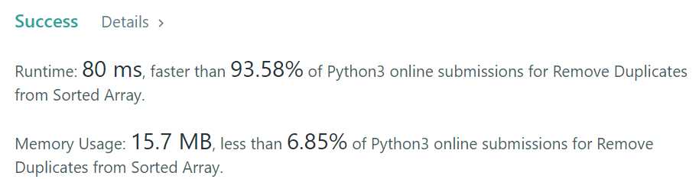

class Solution:

def removeDuplicates(self, nums: List[int]) -> int:

x = 1

for i in range(len(nums)-1):

if(nums[i]!=nums[i+1]):

nums[x] = nums[i+1]

x+=1

return(x)

class Solution:

def removeDuplicates(self, nums: List[int]) -> int:

uniquenums=set(nums)

nums = list(uniquenums)

return len(nums)